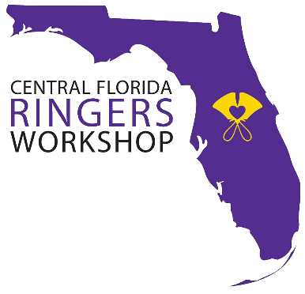
Central Florida Ringers Workshop
September 28, 2019

Earlybird Deadline: August 23, 2019
Registration Deadline: September 15, 2019

Name: |  | Phone Number:
Church/Choir Name:
Address:
City : | Zip Code:
Email Address:
Are you participating in the optional piece?

Group Registrants:
Linear Feet Needed: | Number of 6’ Tables Needed ($12 each):
Positions Open for Orphans:

Individual Registrants:
Are you bringing your own equipment?
Where do you want to ring (treble, battery, bass, low bass)?

Fees
 | Fee |  | Quantity | Total
Earlybird Registration (by 8/23) | $45
Standard Registration (by 9/15) | $55
Student Registration (9/15) | $30
Chaperones (Lunch Only) | $10
Music for Mass Ringing* | $13
Optional Piece (Spirit Dance)* | $4.25
Rental Tables | $12
*You may purchase on your own from your favorite handbell retailer |  | Total Due:

Please mail registration form and check for amount indicated to:

Magic of Bronze
c/o Stephanie Shealey
516 Mockingbird Lane
Altamonte Springs, FL 32714

Make checks payable to:
Magic of Bronze

Registrants
Name |  | Name |  | Name

If you have any questions, please contact Scott Beck (Event Coordinator)
269-330-2317 (cell) | events@magicofbronze.com

